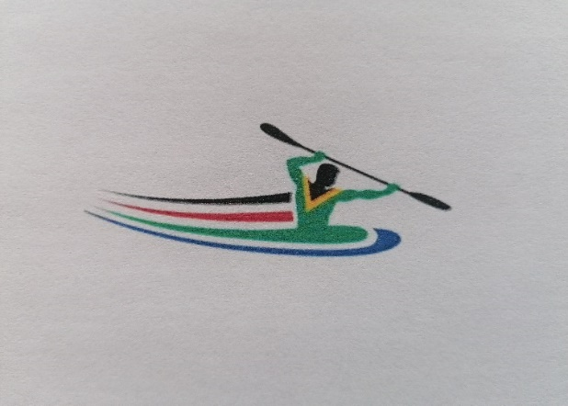
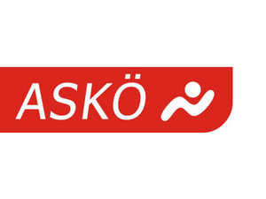
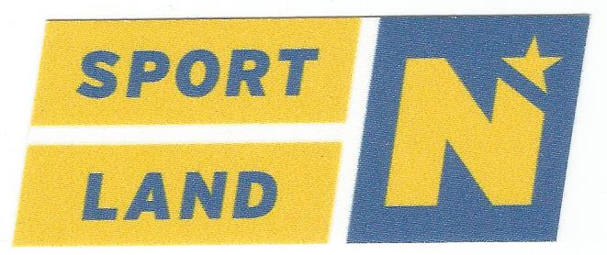
5. Open INTERNATIONAL
Kayak
Int.European Youth Competition
ASKÖ National Championship
July 6-7, 2024
(Entry deadline: Monday, June 24th)

Austrian ASKÖ National Championships: 200m, 500m, 2000m, 5000m (see appendix announcement)
Race order: this depends on the number of entries.
Meldungen: Kretzl Andreas - pruzzo@gmx.at - Tel. +43 676 6393056
Please note that there will be NO race postponements, at most people will be cancelled or places will be filled. From junior children's boat, (if possible) we start and score in age group races to avoid heats!
The message must contain:
1. Race number and name of the race
2. Names and dates of birth of the starters
3. Names of team captains
(maximum 2 people per club)
Only entries that are completed completely and correctly in the registration form are valid!

Life jackets are mandatory for all students and children.!!!!

Registration deadline: Monday 24 June 2024 (please specify year of birth)
Please DO NOT forget the date for the entry deadline, otherwise it will be difficult to create a start list and send it out one week in advance!
Protest fee: 60,-Euro
Overnight stay: It is possible to camp directly at the campsite!
Schloss Leiben with sleeping bag (2 € per person tourist tax)

Entry fee:
 | K1 | K2
Masterclass | 6 € | 8 €
Juniors | 6 € | 8 €
Youth | 3 € | 6 €
Pupils A and B | 3 € | 6 €
Children's boat | 3 € | 6 €

Remorse money and late entries = double entry fee!
Overnight stay: Overnight stay: It is possible to camp directly at the campsite!
Schloss Leiben with sleeping bag (2 € per person tourist tax)
.
Prizes: Honorary Prizes, Cups, Medals (Children1-8, Pupils1-6, Youth1-4, all other classes 1-3)
The organizer reserves the right to make any changes (including security concerns, for example).
Each participant starts at his own risk. The organizer and the organizer do not assume any liability for accidents and other things, not even towards third parties.
The organizer and the organizer reserve the right to cancel the championship or postpone it to a later date in the event of flooding.
Personal data will be stored, insofar as they are necessary for the recording of services/results in connection with participation in this event, and will also be stored in accordance with Art. 17 para. 3 in conjunction with Art. 89 GDPR 0 for archiving purposes in the public interest and legitimate interests of the controller, and
as well as stored and made publicly accessible by the Austrian Federal Sports Organisation BSO, 1040 Vienna, Prinz-Eugen-Str. 12. This is expressly acknowledged by the registered persons

Kretzl Andreas
KC Ybbs
Juniors 2006/2007
Youth 2008/2009
Supporting competition:
SchülerA 2010/2011
Children's boat from 2014

1 | Men's Master Class |  | K1 200m
2 |  |  | K1 500m
3 |  |  | K2 200m
4 |  |  | K2 500m
5 |  |  | C1 200m
6 |  |  | C1 500m
7 | Women's Masterclass |  | K1 200m
8 |  |  | K1 500m
9 |  |  | C1 200m
10 |  |  | C1 500m
11 |  |  | K2 200m
12 |  |  | K2 500m
13 | General Class(Master) |  | K1 200m
14 |  |  | K1 500m
15 |  |  | C1 200m
16 |  |  | C1 500m
17 |  |  | K2 200m
18 |  |  | K2 500m
19 | Men's Juniors |  | K1 200m
20 |  |  | K1 500m
21 |  |  | C1 200m
22 |  |  | C1 500m
23 |  |  | K2 200m
24 |  |  | K2 500m
25 | Women's Juniors |  | K1 200m
26 |  |  | K1 500m
27 |  |  | C1 200m
28 |  |  | C1 500m
29 |  |  | K2 200m
30 |  |  | K2 500m
31 | Male Youth |  | K1 200m
32 |  |  | K1 500m
33 |  |  | C1 200m
34 |  |  | C1 500m
35 |  |  | K2 200m
36 |  |  | K2 500m
37 | Female Youth |  | K1 200m
38 |  |  | K1 500m
39 |  |  | C1 200m
40 |  |  | C1 500m
41 |  |  | K2 200m
42 |  |  | K2 500m
43 | Male Pupils A |  | K1 200m
44 |  |  | K1 500m
45 |  |  | C1 200m
46 |  |  | C1 500m
47 |  |  | K2 200m
48 |  |  | K2 500m
49 | Female Pupils A |  | K1 200m
50 |  |  | K1 500m
51 |  |  | C1 200m
52 |  |  | C1 500m
53 |  |  | K2 200m
54 |  |  | K2 500m
55 | Male Pupils B |  | K1 200m
56 |  |  | K1 500m
57 |  |  | C1 200m
58 |  |  | C1 500m
59 |  |  | K2 200m
60 |  |  | K2 500m
61 | Female Pupils B |  | K1 200m
62 |  |  | K1 500m
63 |  |  | C1 200m
64 |  |  | C1 500m
65 |  |  | K2 200m
66 |  |  | K2 500m
67 | Children's boat male |  | K1 200m
68 |  |  | K1 500m
69 |  |  | K2 200m
70 |  |  | K2 500m
71 | Children's boat female |  | K1 200m
72 |  |  | K1 500m
73 |  |  | K2 200m
74 |  |  | K2 500m
75 | Children's boat male |  | K1 2000m
76 | Children's boat female |  | K1 2000m
77 | Pupil B male |  | K1 2000m
78 | Pupil B male |  | C1 2000m
79 | Student B female |  | K1 2000m
80 | Student B female |  | C1 2000m
81 | Student A male |  | K1 2000m
82 | Student A male |  | C1 2000m
83 | Student A female |  | K1 2000m
84 | Student A female |  | C1 2000m
85 | Youth Male |  | K1 2000m
86 | Youth Male |  | C1 2000m
87 | Youth Female |  | K1 2000m
88 | Youth Female |  | C1 2000m
89 | Men's Master Class |  | K1 5000m
90 | Men's Master Class |  | C1 5000m
91 | Women's Masterclass |  | K1 5000m
92 | Women's Masterclass |  | C1 5000m
93 | Men's Juniors |  | K1 5000m
94 | Men's Juniors |  | C1 5000m
95 | Women's Juniors |  | K1 5000m
96 | Women's Juniors |  | C1 5000m
97 | Children's boat male |  | K2 2000m
98 | Children's boat female |  | K2 2000m
99 | Pupil B male |  | K2 2000m
100 | Student B female |  | K2 2000m
101 | Student A male |  | K2 2000m
102 | Student A female |  | K2 2000m
103 | Youth Male |  | K2 2000m
104 | Youth Female |  | K2 2000m
105 | Men's Master Class |  | K2 5000m
106 | Women's Masterclass |  | K2 5000m
107 | Men's Juniors |  | K2 5000m
108 | Women's Juniors |  | K2 5000m

Kretzl Andreas +43 676 6393056
KC Ybbs

